Python Programming (R1UC427B)
Adarsh Srivastava (24SCSE1010698) Section – 3 Lab P1
Practical 3: Conditional Statements
3.1 Program Using Simple if Statement
Code :
num = int(input("Enter a number: "))
if num > 0:
print("The number is positive")
Output :
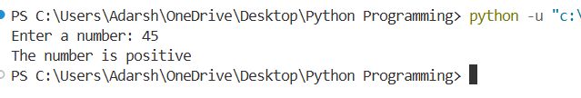

3.2 Program Using if–else Statement
Code :
num = int(input("Enter a number: "))
if num % 2 == 0:
print("The number is Even")
else:print("The number is Odd")
Output :
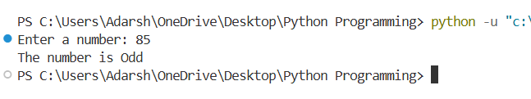

3.3 Program Using Nested if–else
Code :
num = int(input("Enter a number: "))
if num >= 0:
if num == 0:
print("The number is Zero")
else:
print("The number is Positive")
else:
print("The number is Negative")
Output :
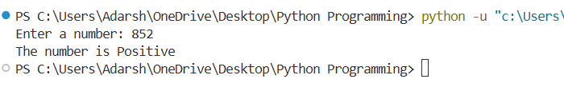
3.4 Program Using elif Ladder
Code :
marks = int(input("Enter your marks: "))
if marks >= 90:
print("Grade A")
elif marks >= 75:
print("Grade B")
elif marks >= 60:
print("Grade C")
elif marks >= 50:
print("Grade D")
else:
print("Fail")
Output :
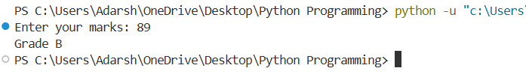
- Exercise
E1: Write a Python program to check whether a number is positive, negative, or zero.
Code :
num = int(input("Enter a number: "))
if num > 0:
print("The number is Positive")
elif num < 0:
print("The number is Negative")
else:
print("The number is Zero")
Output :
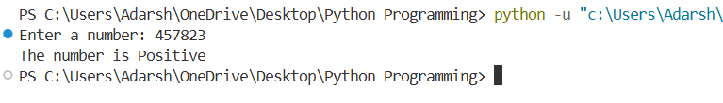
E2: Write a program to find the largest of two numbers using if–else.
Code :
num1 = int(input("Enter first number: "))
num2 = int(input("Enter second number: "))
if num1 > num2:
print("The largest number is:", num1)
else:
print("The largest number is:", num2)
Output :
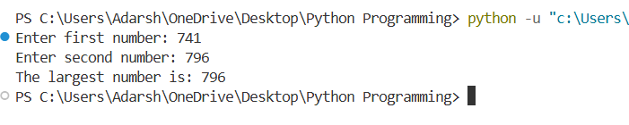
E3 : Write a Python program to calculate electricity bill using elif ladder.
Code :
units = int(input("Enter electricity units consumed: "))
bill = 0
if units <= 100:
bill = units * 1.5
elif units <= 200:
bill = units * 2.5
elif units <= 300:
bill = units * 4
else:
bill = units * 5
print("Total Electricity Bill =", bill)
Output :
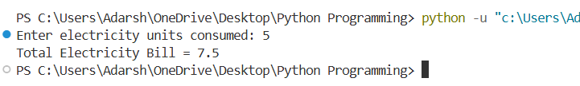

Practical 4: Looping Statements
4.1 To print numbers from 1 to 5 using a for loop.
Code :
for i in range(1, 6):
print(i)
Output :
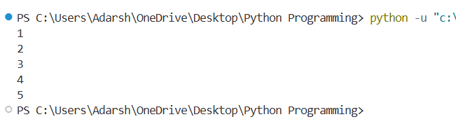
4.2 To print numbers from 1 to 5 using a while loop
Code :
i = 1
while i <= 5:
print(i)
i = i + 1
Output :
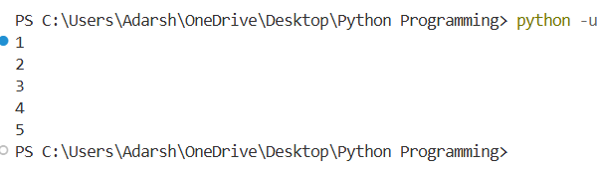
4.3 To print a star pattern using nested for loops.
Code :
rows = 5
for i in range(1, rows + 1):
for j in range(i):
print("*", end=" ")
print()
Output :
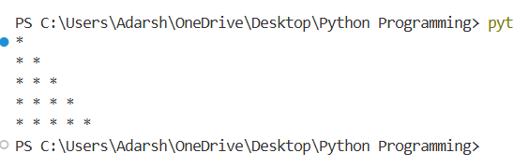
4.4 To demonstrate the break statement in a loop
Code :
for i in range(1, 10):
if i == 5:
break
print(i)
Output :
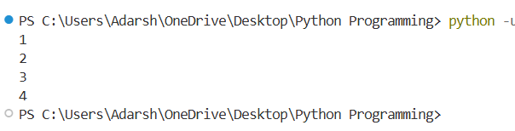
4.5 To demonstrate the continue statement in a loop.
Code :
for i in range(1, 10):
if i == 5:
continue
print(i)
Output :
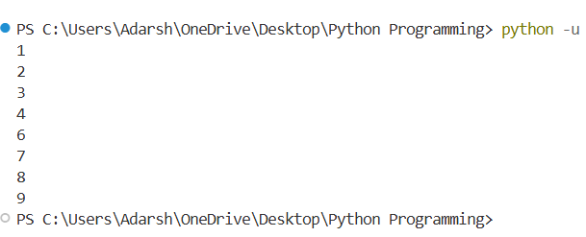

- Exercise
E1: WAP to print the multiplication table of a given number..
Code :
num = int(input("Enter a number: "))
for i in range(1, 11):
print(num, "x", i, "=", num * i)
Output :
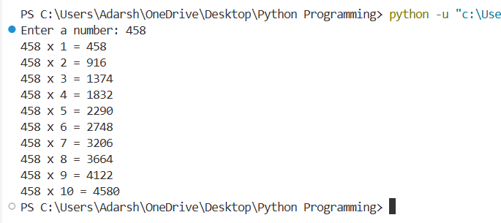
E2: WAP to find the sum of first N natural numbers using a loop
Code :
n = int(input("Enter a number: "))
sum = 0
for i in range(1, n + 1):
sum = sum + i
print("The sum of first", n, "natural numbers is:", sum)
Output :
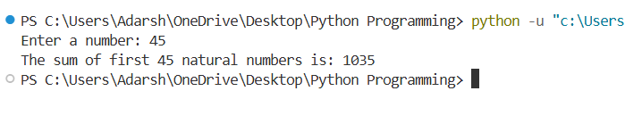
E3: WAP to print Fibonacci series using a loop.
Code :
n = int(input("Enter number of terms: "))
a = 0
b = 1
for i in range(n):
print(a)
c = a + b
a = b
b = c
Output :
